PROPAGANDA Techiques
Name Calling | Negative words are used to create an unfavorable opinion of the competition in the viewer's mind. | 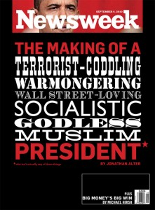
Glittering Generalities | Use of virtue words; the opposite of name calling, i.e., links a person, or idea, to a positive symbol. Examples: democracy, patriotism, family | "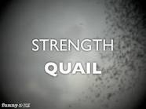
Testimonial/Endorsement | An important person or famous figure endorses a product. | 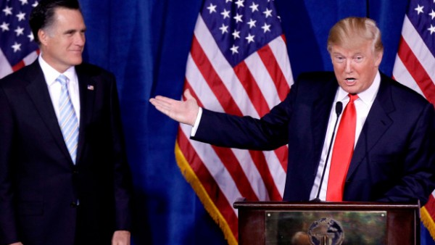
Plain Folks | attempt to convince the audience that a prominent person and his ideas are “one of the regular people” | 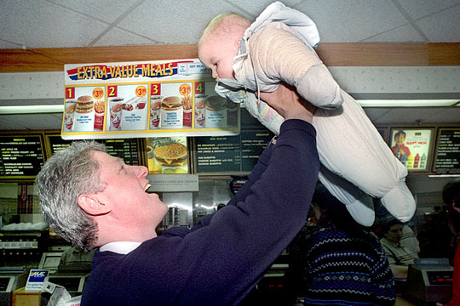
Fear | plays on deep-seated fears; warns the audience that disaster will result if they do not follow a particular course of action | 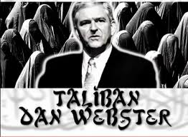
Band Wagon | This technique tries to persuade everyone to join in and do the same thing. | 